 | 12.1.19 Editors - Geometry Nodes Editor - Header - Add Menu - Texture
Table of content
Detailed table of content 1
Add menu - Texture 2
Gradient Texture 2
Noise Texture 3
Voronoi Texture 4
White Noise Texture 5

Detailed table of content
Detailed table of content
Detailed table of content 1
Add menu - Texture 2
Gradient Texture 2
Inputs 2
Vector 2
Properties 2
Gradient Type 2
Output 2
Factor 2
Color 3
Noise Texture 3
Inputs 3
Vector 3
Scale 3
Detail 3
Roughness 3
Distortion 3
Properties 3
Dimensions 3
Output 3
Factor 3
Color 3
Voronoi Texture 4
Inputs 4
Vector 4
Scale 4
Randomness 4
Properties 4
Dimensions 4
Feature Output 4
F1 4
F2 4
Smooth F1 4
Distance to Edge 4
N-Sphere Radius 4
Distance Metric 5
Output 5
Factor 5
Color 5
White Noise Texture 5
Inputs 5
Vector 5
Properties 5
Gradient Type 5
Output 5
Vector 5
Color 5

Add menu - Texture
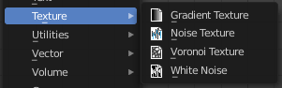
Texture nodes.

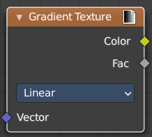
Gradient Texture
Add a gradient texture.

Inputs

Vector
Vector input.

Properties

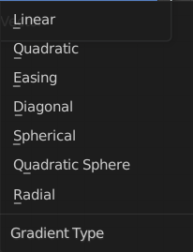
Gradient Type
What gradient type to use.

Output

Factor
Factor output.

Color

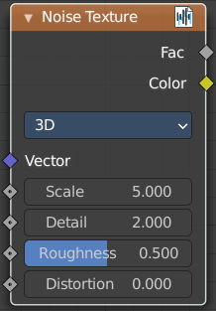
Noise Texture
Add a noise texture.

Inputs

Vector
Vector input

Scale
The scale of the noise texture.

Detail
The detail of the noise texture.

Roughness
The roughness of the noise texture.

Distortion
The distortion of the noise texture.

Properties

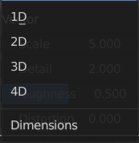
Dimensions
How many dimensions to use for the noise texture.

Output

Factor
Factor output.

Color
Color output.

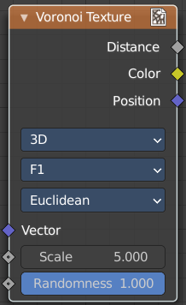
Voronoi Texture
Add a voronoi texture.

Inputs

Vector
Vector input

Scale
The scale of the voronoi texture.

Randomness
The detail of the voronoi texture.

Properties

Dimensions
How many dimensions to use for the voronoi texture.

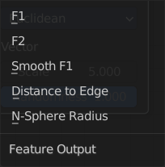
Feature Output
Feature output mode.

F1
Computes the distance to the closest point as well as its position and color.

F2
Computes the distance to the second closest point as well as its position and color.

Smooth F1
Smoothed version of F1.Weighted sum of neighbor voronoi cells.

Distance to Edge
Computes the distance to the edge of the voronoi cell.

N-Sphere Radius
Computes the radius of the n-sphere inscribed in the voronoi cell.

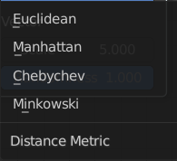
Distance Metric
Distance calculation mode. The modes are different mathematical methods.

Output

Factor
Factor output.

Color
Color output.

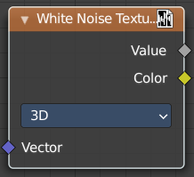
White Noise Texture
Add a white noise texture.

Inputs

Vector
Vector input.

Properties

Gradient Type
What gradient type to use.

Output

Vector
Factor output.

Color
Color output.

